LOT  08809 | ec-fdgfdg  gghgfgffdfgggf  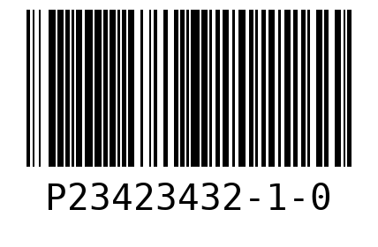  WO 15562  LOT 08809  QTY 10
ec-jhgjkkh
jgjhgjgjghg
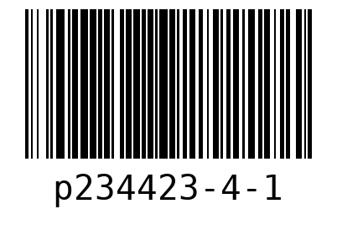
WO 15325
LOT 08809
QTY 25

SHEET  1 | ec-fdgfdg  gghgfgffdfgggf  WO 15562  LOT 08809
ec-jhgjkkh  jgjhgjgjghg  WO 15325  LOT 08809 | ec-jhgjkkh  jgjhgjgjghg  WO 15325  LOT 08809
ec-jhgjkkh  jgjhgjgjghg  WO 15325  LOT 08809 | ec-jhgjkkh  jgjhgjgjghg  WO 15325  LOT 08809

ec-jhgjkkh  jgjhgjgjghg  WO 15325  LOT 08809 | ec-jhgjkkh  jgjhgjgjghg  WO 15325  LOT 08809
ec-jhgjkkh  jgjhgjgjghg  WO 15325  LOT 08809 | ec-jhgjkkh  jgjhgjgjghg  WO 15325  LOT 08809
SHEET  2 | ec-fdgfdg  gghgfgffdfgggf  WO 15562  LOT 08809

ec-fdgfdg  gghgfgffdfgggf  WO 15562  LOT 08809 | ec-fdgfdg  gghgfgffdfgggf  WO 15562  LOT 08809
ec-fdgfdg  gghgfgffdfgggf  WO 15562  LOT 08809 | ec-fdgfdg  gghgfgffdfgggf  WO 15562  LOT 08809
ec-fdgfdg  gghgfgffdfgggf  WO 15562  LOT 08809 | ec-fdgfdg  gghgfgffdfgggf  WO 15562  LOT 08809

ec-jhgjkkh  jgjhgjgjghg  WO 15325  LOT 08809 | ec-jhgjkkh  jgjhgjgjghg  WO 15325  LOT 08809
ec-jhgjkkh  jgjhgjgjghg  WO 15325  LOT 08809 | ec-jhgjkkh  jgjhgjgjghg  WO 15325  LOT 08809
ec-jhgjkkh  jgjhgjgjghg  WO 15325  LOT 08809 | ec-jhgjkkh  jgjhgjgjghg  WO 15325  LOT 08809

ec-jhgjkkh  jgjhgjgjghg  WO 15325  LOT 08809 | ec-jhgjkkh  jgjhgjgjghg  WO 15325  LOT 08809
ec-jhgjkkh  jgjhgjgjghg  WO 15325  LOT 08809 | ec-jhgjkkh  jgjhgjgjghg  WO 15325  LOT 08809
SHEET  3 | ec-fdgfdg  gghgfgffdfgggf  WO 15562  LOT 08809

ec-fdgfdg  gghgfgffdfgggf  WO 15562  LOT 08809 | ec-jhgjkkh  jgjhgjgjghg  WO 15325  LOT 08809
ec-jhgjkkh  jgjhgjgjghg  WO 15325  LOT 08809 | ec-jhgjkkh  jgjhgjgjghg  WO 15325  LOT 08809
ec-jhgjkkh  jgjhgjgjghg  WO 15325  LOT 08809 | ec-jhgjkkh  jgjhgjgjghg  WO 15325  LOT 08809

ec-jhgjkkh  jgjhgjgjghg  WO 15325  LOT 08809 | ec-jhgjkkh  jgjhgjgjghg  WO 15325  LOT 08809

